Results of the Fourth Digital Asset Management Salary Survey

Comparisons of Changing Compensation, Demographics, and Employment over Time compiled for DAM News

By E. Keathley, Lisa Grimm, Deb Fanslow, and Jennifer Tyner

Contents

Introduction 2

Key Findings 3

Demographics 3

DAM Salaries Overall 4

DAM Salaries by Experience 6

Correlations by Gender 7

Correlations by Educational Background 7

Salaries by Employer 8

The Shift to Remote Work and the End of Regionalism 10

Roles and Responsibilities 11

Conclusions 14

Further Reading 14

# Introduction

This article covers the fourth iteration of the Digital Asset Management Salary Survey and compares current results with previous findings.

The Digital Asset Management Salary Survey was previously published in 2012 and 2015 by the (now defunct) DAM Foundation, and again in 2017 by DAM News. The survey was distributed to those working with DAM-type systems to better define the emerging profession they seek to represent. Given the cost and effort of DAM installation, hiring and retaining the best Digital Asset Managers is crucial to producing an ROI (Return on Investment) for DAM systems.

This fourth salary survey uses the same questions and a similar methodology to its predecessors, shares some of the same authors, and will first be published in DAM News. By surveying successful Digital Asset Managers who are engaged with their profession, DAM News hopes to assist employers in avoiding system failure by collecting and disseminating information on professionals who are successful in this new field. Through the process of creating linear sets of data, changes in the demographics and pay of the new workforce can be monitored and discussed based on facts instead of anecdotal evidence.

Survey participants were asked to provide information based on their previous twelve months of work. The survey was open online from September 11th until December 11th, 2024. One hundred and forty-nine participants contributed to the data, and it is hoped that more Digital Asset Managers can be recruited to take part in future data gathering efforts. The survey was made available via Google Forms, and was constructed using Google Sheets, which provided easily retrievable metrics. The survey was promoted within the DAM community via DAM News, social media and LinkedIn groups for DAM professionals. The inherent bias of the survey is therefore towards a self-selected audience that is more likely to be engaged in professional development, conference attendance, and social media. The authors of this article realize that many more conclusions, correlations, and debates are immediately evident when the collected data is studied. However, by making the data set publicly available, the authors hope to encourage and foster further writing and scholarship of our emerging profession. The raw data collected for the survey is available freely (scrubbed of any data that might directly identify participants). This article will break down survey results by demographic, employment, and compensation data from the largest groups of participants in each category and discuss whether the reporting has remained static or changed.

# Key Findings

Substantial changes in the compensation, demographics, and work environments of Digital Asset Managers can be tracked across the four surveys of the profession. Wages have risen, the profession has greyed, and the transition to predominantly remote work can be seen. Digital Asset Management is a field with high professional mobility, with the average time spent at a current employer just over four years. The transition to a majority remote work environment has weakened the correlation of location to wages, further leading to professional experience dictating remuneration. Many fewer Digital Asset Managers work solo, or as “lone arrangers”, with a shift towards more collaborative and/or team environments represented. There is no longer a correlation between where a Digital Asset Manager sits in an organization, or type of employer, and how they are paid. Pay for Digital Asset Managers is most strongly correlated to age and years of experience in the field, and no other factors.

# Demographics

There have been substantial changes in the reported general demographics of Digital Asset Managers as a whole (numbers have been rounded to the nearest whole number, and thus percentages may not be exactly 100%). For the first time since the survey was conducted, non-white persons accounted for over a quarter of those reporting, with this being the largest shift by percentage (up twelve percentage points) of any other data gathered. Fewer younger workers reported in this round than previously, with those under thirty-five years of age losing a total of nine percentage points across the two youngest categories of respondents. The demographic shift to a more female workforce in Digital Asset Management continued as expected, showing a steady drop in male workers interested in the field.

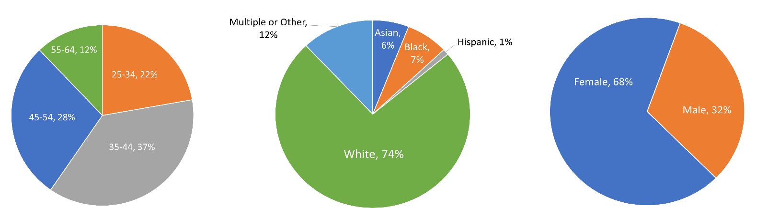

*Figure 1: Survey Response by Age, Race, and Gender, Digital Asset Management Salary Survey, 2024*

|  |  |  |  |  |
| --- | --- | --- | --- | --- |
| **Age** | **2012** | **2014** | **2017** | **2024** |
| 18-24 | 1% | 1% | 1% | 0% |
| 25-34 | 29% | 35% | 30% | 22% |
| 35-44 | 33% | 29% | 34% | 37% |
| 45-54 | 20% | 26% | 24% | 28% |
| 55-64 | 17% | 10% | 11% | 12% |
|  |  |  |  |  |
| **Race** | **2012** | **2014** | **2017** | **2024** |
| Asian | 4% | 4% | 6% | 6% |
| Black | 4% | 5% | 4% | 7% |
| Hispanic | 6% | 3% | 4% | 1% |
| White | 85% | 85% | 86% | 74% |
| Multiple or Other | - | - | - | 12% |
|  |  |  |  |  |
| **Gender** | **2012** | **2014** | **2017** | **2024** |
| Female | 58% | 61% | 63% | 68% |
| Male | 42% | 39% | 35% | 32% |
| Non binary | - | - | 0% | 0% |
| Prefer not to say | - | - | 2% | 0% |

*Chart 1: Digital Asset Management Salary Survey results from 2012, 2014, 2017, and 2024 showing changes in responses to Age, Race, and Gender*

# DAM Salaries Overall

The authors are happy to report that salaries have risen both overall in the field and among full-time Digital Asset Managers since the last survey.

|  |  |  |  |  |
| --- | --- | --- | --- | --- |
|  | **2012** | **2014** | **2017** | **2024** |
| Median | $65,000 | $60,000 | $65,500 | $99,000 |
| Mean | $81,448 | $69,865 | $72,000 | $109,645 |

*Chart 2: Average Reported Salaries of Full Time Digital Asset Managers in USD, Digital Asset Management Salary Survey 2024*

The revival of this salary survey by the original author and other collaborators was due in no small part to anecdotal evidence that wages in the field had stagnated or even shrunk in the last decade. As the data gathered shows, this is simply not true. This round of the salary survey was missing some of the outlier high end reporters of the past (no respondent reported a salary above $350,000), and fewer part-time workers reported. Earnings remained most strongly related to age, so with no respondents this time in the youngest age group (those under twenty-five), the survey also missed the lowest outlier, lower end reporters. What remains is likely the best picture of the middle of the profession ever gathered by this survey. There were also more respondents than ever, giving a better sample overall.

Respondents to the survey could be broken down into three categories by reported earnings. The lower third earned $82,000 per year or less. The middle third earned between $83,000 and $113,000 annually. The upper third of earners made between $114,000 and $350,000.

There were no correlations to be found between reported titles or duties and salaries. There was very little correlation between the hours worked and salaries paid. The lower third of earners were more likely to be younger and were more likely to be pursuing more education. The middle third of earners were more likely to be women in the middle of their careers. The top third of earners had only one thing in common: they were slightly more likely to be older than the middle third and had a large age gap with the bottom third of earners.

The anecdotal evidence that this survey refutes, in the form of low-paying Digital Asset Management positions frequently posted on LinkedIn, skews perception of the field. The authors would like to propose a theory behind why workers feel that very low paying jobs in the field are proliferating. Lower paying jobs in DAM (less than $100,000 USD, the mode of reported salaries) are frequently posted online for longer periods of time simply because these jobs are more difficult to fill. When jobs in the lower third of reported salaries ($82,000 USD and below) are filled in DAM, the employees are more likely to be young, at the start of their career, and thus more likely to leave as they move up in experience, leading to the job being posted again. When the same job with a low salary is posted repeatedly, this also leads to the perception that more DAM jobs have low pay. In short – the jobs that pay well aren’t available for very long, if they are posted publicly at all. Digital Asset Managers may have the perception that all the jobs out there pay poorly simply because the poorly paid jobs are more visible online.

|  |  |  |  |
| --- | --- | --- | --- |
| **Age** | **Average Reported Salary** | **Mode Reported Salary** | **Median Reported Salary** |
| 25-34 | $87,747 | $90,000 | $80,000 |
| 35-44 | $97,274 | $100,000 | $90,000 |
| 45-54 | $123,758 | $130,000 | $116,500 |
| 55-64 | $146,894 | $150,000 | $135,000 |

*Chart 3: Reported Salaries by Age Group, Digital Asset Management Salary Survey 2024*

# DAM Salaries by Experience

In the third salary survey published in 2018, it was hoped by the authors that “As the demand for highly skilled labor in this market rises, it is hoped that salaries will rise as well.” This appears to have been somewhat true, though the high inflation of the last few years in the United States makes it difficult to determine if demand or high prices have pushed wages upward. The authors also hoped in eight years ago that “experience in the field should be the determining factor” for Digital Asset Management wages. Luckily, this seems now to broadly be true, as years in the field now translate into higher wages.

|  |  |  |
| --- | --- | --- |
| **Earnings Per Year** | **Average Years with Current Employer** | **Average Years in Current Profession** |
| 0-82k | 3.6 | 6.8 |
| 83k-113k | 4.8 | 9.1 |
| 114k-350k | 4 | 17 |

*Chart 4: Reported average years with current employer and average years in current profession broken out into the lower, middle, and top thirds of reported earners.*

High professional mobility in the field continues to be the norm, with survey respondents spending an average of just 4.18 years in their current jobs. Clear divisions among respondents who earned more could be seen correlated with years in the profession.

# Correlations by Gender

The fourth iteration of the salary survey showed the closest parity of median salaries between genders to date.

|  |  |  |  |
| --- | --- | --- | --- |
|  | **2012 Mean** | **2012 Median** | **2012 Mode** |
| Female | $64,833 | $55,000 | $50,000 |
| Male | $85,619 | $84,000 | $100,000 |
|  |  |  |  |
|  | **2014 Mean** | **2014 Median** | **2014 Mode** |
| Female | $65,542 | $53,000 | $50,000 |
| Male | $73,423 | $60,000 | $60,000 |
|  |  |  |  |
|  | **2017 Mean** | **2017 Median** | **2017 Mode** |
| Female | $69,795 | $63,600 | $59,000 |
| Male | $73,640 | $68,000 | $72,000 |
|  |  |  |  |
|  | **2024 Mean** | **2024 Median** | **2024 Mode** |
| Female | $106,930 | $97,720 | $100,000 |
| Male | $112,162 | $98,503 | $80,000 |

*Chart 5: Reported earnings by gender overtime from the Digital Asset Management Salary Surveys in 2012, 2014, 2017, and 2024.*

For the first time since the survey has been conducted, women scored higher in a salary category than their male counterparts, which being the mode number for earnings. The most reported salary in a category for women was higher than that of men by twenty thousand dollars. While men still have a higher average salary due to more men with seniority in the profession, the number of women surveyed means that the mode for female digital asset managers is the mode for all digital asset managers. With the median between the genders approaching parity, and retirement for the highest male earners on the horizon, it is possible that gender will continue to play less of a role in remuneration in the future in this field.

# Correlations by Educational Background

As with previous Digital Asset Management Salary Surveys, there remains no correlation between pay and education. In 2014, it was reported that “In 2012 there were no MLS/MLIS holders over 35; in 2014 those with a library degree could be found in every age cohort under 55.” The MLS/MLIS is now the most reported graduate degree. While six respondents said they planned to pursue or were pursuing a MBA in the future, only two Digital Asset Managers reported having one. While previous surveys correlated a MBA with higher earnings, this is no longer the case. Likewise, while six participants also planned to pursue a PhD in the future, possessing a PhD did not translate into higher earnings in this field for the four who reported holding a doctorate. The most reported form of continuing education planned by respondents was participation in a certificate program.

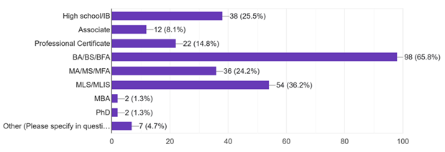

*Figure 2: All reported education from the 2024 Digital Asset Management Salary. Respondents may report multiple degrees or certificates.*

# Salaries by Employer

The first two DAM Salary Surveys attempted to break out salaries by type of employer, but by 2017, “the growth of DAM as a key part of the digital ecosystem across the board exploded, with responses across industries and verticals”, meaning that so many types of industries were represented that it was difficult to make any correlations in this area. While employers from producers of consumer products remain the most likely to employ digital asset managers, numbers across other industries have varied. Digital Asset Management systems truly can be found in every workplace.

A breakout of the top employers in each earning bracket shows the issue with trying to generalize about pay by employer type.

|  |  |
| --- | --- |
| **Top Employers for Digital Asset Managers Making 0-82k per year, 2024** | |
| Consumer Product Goods or Manufacturing | 20% |
| Media & Entertainment | 16% |
| Academic/Educational institution or company | 8% |
| Sports | 8% |
| DAM Vendor or DAM Consultancy (the business of DAM) | 5% |
|  |  |
| **Top Employers for Digital Asset Managers Making 83k-113k per year, 2024** |  |
| Consumer Product Goods or Manufacturing | 12% |
| Media & Entertainment | 12% |
| Other non-profit organization (charity, or other cultural organization) | 12% |
| Healthcare/Hospital/Pharmaceutical | 8% |
| Banking and Museum (tied, both 5%) | 5% |
|  |  |
| **Top Employers for Digital Asset Managers Making 114k-350k per year, 2024** |  |
| Consumer Product Goods or Manufacturing | 18% |
| DAM Vendor or DAM Consultancy (the business of DAM) | 18% |
| Media & Entertainment | 16% |
| Healthcare/Hospital/Pharmaceutical | 12% |
| Other for-profit organization | 8% |

*Chart 6: Top five employment categories reported in the lower, middle, and top thirds of earners in the 2024 Digital Asset Management Salary Survey.*

The three top employers of Digital Asset Managers (Consumer Product Goods, 16.8% of reported employers; Media and Entertainment companies, 14.8% of reported employers; and DAM Vendor or Consultancy, 10.1% of reported employers) were represented across all three categories of earnings. This data shows again that the only true correlation to salaries paid in the profession is years of experience. While Academic employers were over-represented in the lowest salary bracket, it should be noted that academic employees appeared in all three earnings categories. Digital Asset Management systems can now be found truly everywhere, with forty-one different employer categories represented in the 2024 DAM salary survey.

# The Shift to Remote Work and the End of Regionalism

The first two Digital Asset Salary Surveys did not ask participants about remote work; the questions “Do you work remotely during all or part of your work week?” and “If you answered yes to question #5, on average, how often do you work remotely?” were added to the third survey in 2017 and were asked a second time in 2024. In 2017, just 53% of Digital Asset Managers surveyed reported the ability to work remotely; now all but 6% are allowed to work someplace other than their office. Of the nine respondents who were not allowed to work remotely, six were in the lowest third bracket of reported salaries and three were in the top third of reported salaries.

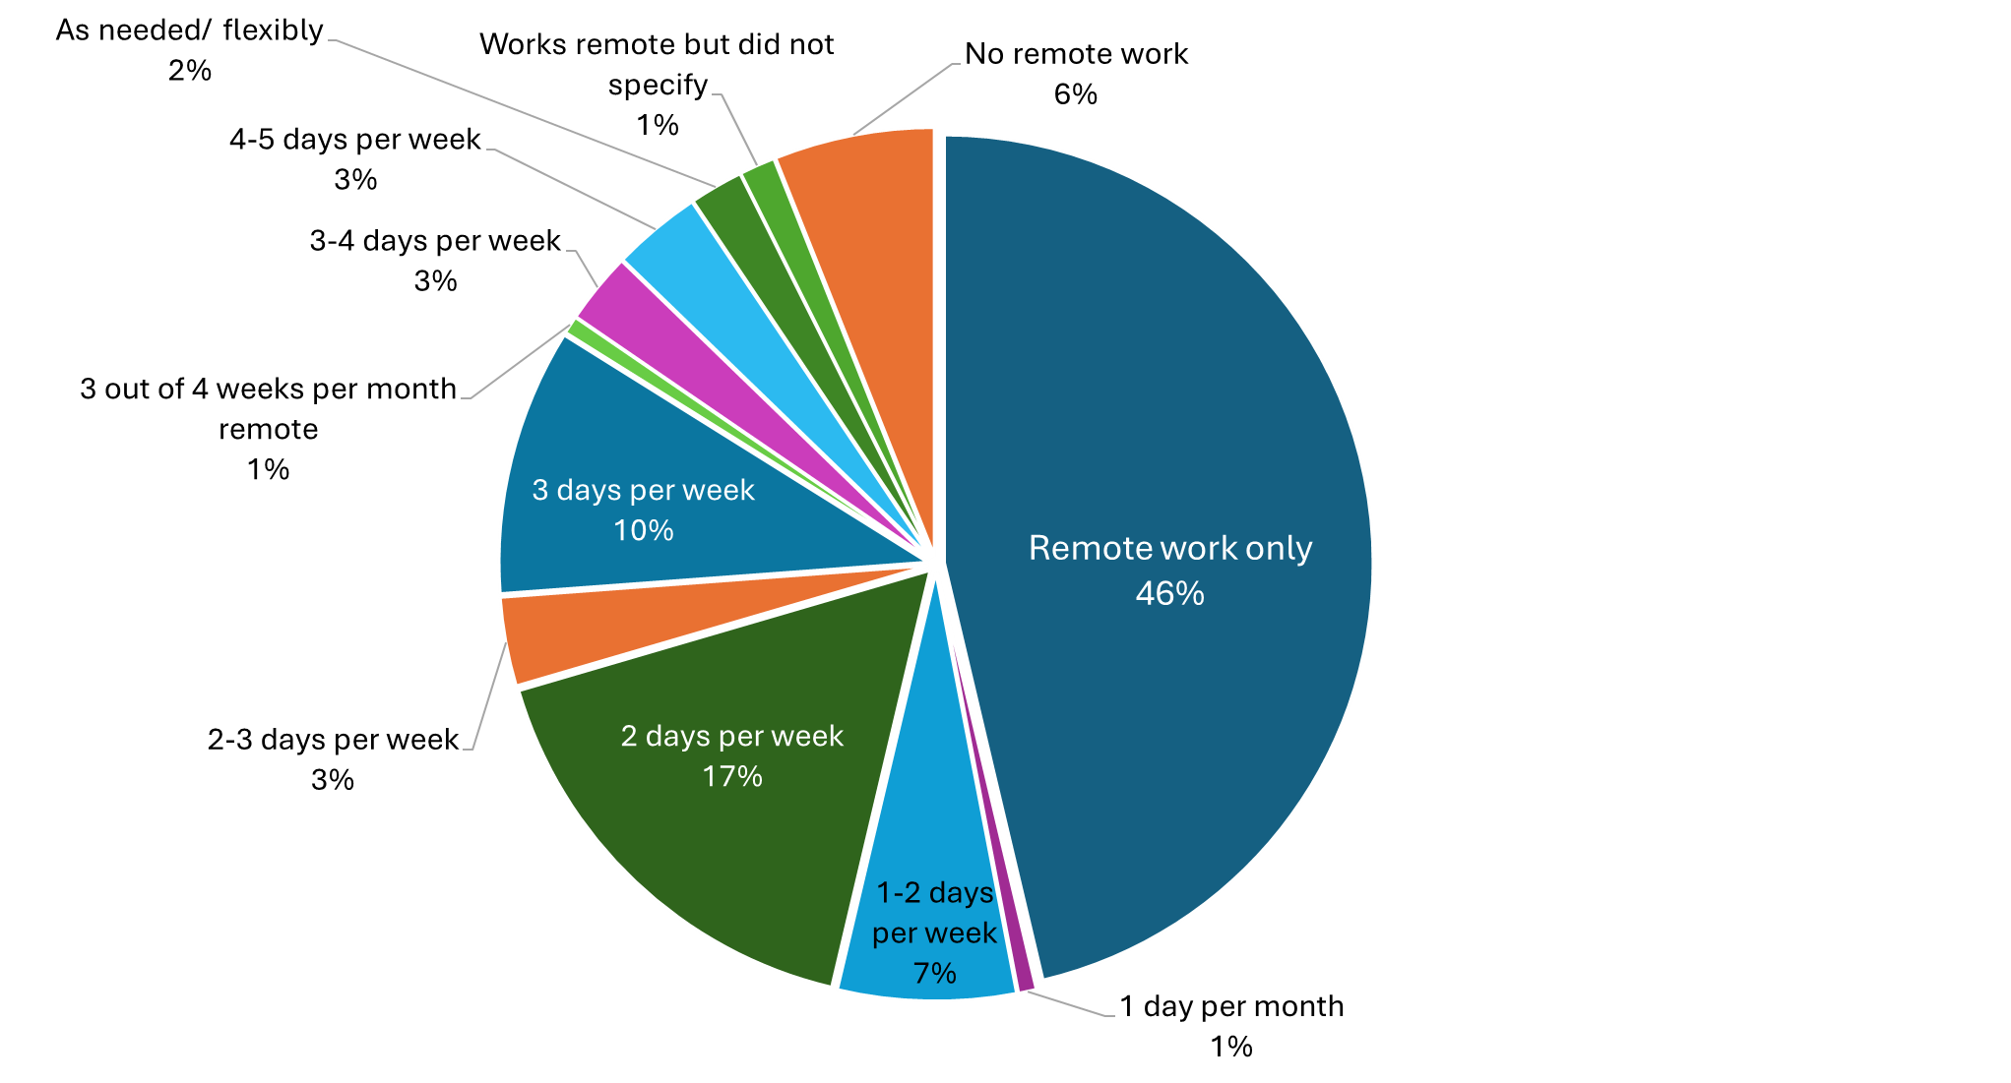

*Figure 3: Answers to the question “How often do you work remotely?” from the 2024 Digital Asset Management Salary Survey*

In the published findings of the second salary survey, the authors noted that

“The drop in average salary may reflect the globalization of DAM use - that is, Digital Asset Management systems are now employing talent in geographic regions where the pay is, on average, much less than in the traditional media centers of London, New York, and Southern California.”

This was in keeping with payment practices at the time, where regions with more expensive costs of living often paid higher wages. However, with work arrangements largely now decoupled from location, it again appears that work experience is the only correlation in Digital Asset Management to earnings.

# Roles and Responsibilities

One of the largest changes in responses to the Digital Asset Management Salary Survey was the decline in “Lone Arrangers”. Anecdotal evidence in the first two surveys showed that the majority of Digital Asset Managers were working alone, and a question asked in the 2017 survey confirmed that suspicion. However, seven years later, most respondents were working in teams. This dramatic rise in the number of respondents working in teams may be an over-representation in the sample set though, as members of a team may have been more likely to recruit their co-workers to participate. Still, the big shift in DAMs operated by teams rather than individuals likely points to a shift towards more collaborative work in this professional space.

|  |  |
| --- | --- |
| **Self- Reported Solo DAM Administrators/Lone Arrangers** |  |
| 2017 | 64.90% |
| 2024 | 38.26% |

*Chart 7: Percentage of respondents who reported working solo or being “lone arrangers” in the 2017 and 2024 Digital Asset Management Salary Surveys.*

Another question introduced in 2017, “What is your DAM user base?” proved useful in showing continued shift in the use of DAM overall. An increase in public facing DAMs is expected in the future, as these content management systems are increasingly found in cultural institutions like museums. The majority of DAMs still serve an enterprise/entire organization.

|  |  |  |
| --- | --- | --- |
| **What is Your DAM User base?** | **2017** | **2024** |
| Enterprise | 46.9% | 57.1% |
| General public | 0.0% | 2.7% |
| Multiple workgroups/departments | 48.7% | 34.7% |
| Select Subscribers | 0.0% | 2.0% |
| Single workgroup/department | 4.4% | 3.4% |

*Chart 8: The user base of Digital Asset Management systems by survey respondents*

Where Digital Asset Managers sit within an organisation continued to be varied across all types of employers. In all four iterations of the survey, Archives/Special Collections, Creative/Design, and Marketing/Brand Management appeared in the top five functional units of an organization where Digital Asset Managers might sit.

|  |  |
| --- | --- |
| **2024** |  |
| Archives and Special Collections | 12.30% |
| Creative/Design Team | 24.70% |
| Marketing/Brand Management* | 40.40% |
| Media Library/Video Library | 19.20% |
| Photo and Video Department | 17.10% |

|  |  |
| --- | --- |
| **2017** |  |
| Archives/special collections | 14% |
| Creative/Design Team | 12.28% |
| IT | 8.77% |
| Marketing/Brand Management* | 33.30% |
| Media Library/Video Library | 14.91% |

|  |  |
| --- | --- |
| **2014** |  |
| Archives/special collections | 9.57% |
| Brand Management* | 5.22% |
| Creative/Design Team | 20% |
| Marketing | 17.39% |
| Media Library/Video Library | 13.91% |

|  |  |
| --- | --- |
| **2012** |  |
| Archives/special collections | 9.82% |
| Creative/Design Team | 20.54% |
| Marketing* | 21.43% |
| Media Library/Video Library | 16.07% |
| Video production | 6.25% |

*\* Brand Management and Marketing were listed as two separate functional units within an organization until the 2017 version of the survey, where they were merged.*

*Chart 9: Top five reported functional units where Digital Asset Managers were assigned within their organizations across the four iterations of the Digital Asset Salary Survey.*

A rise in Digital Asset Managers reporting that they are in Cataloging/Collections Information units was notable in the 2024 survey. A new category, Data Governance, was added to the survey this year.

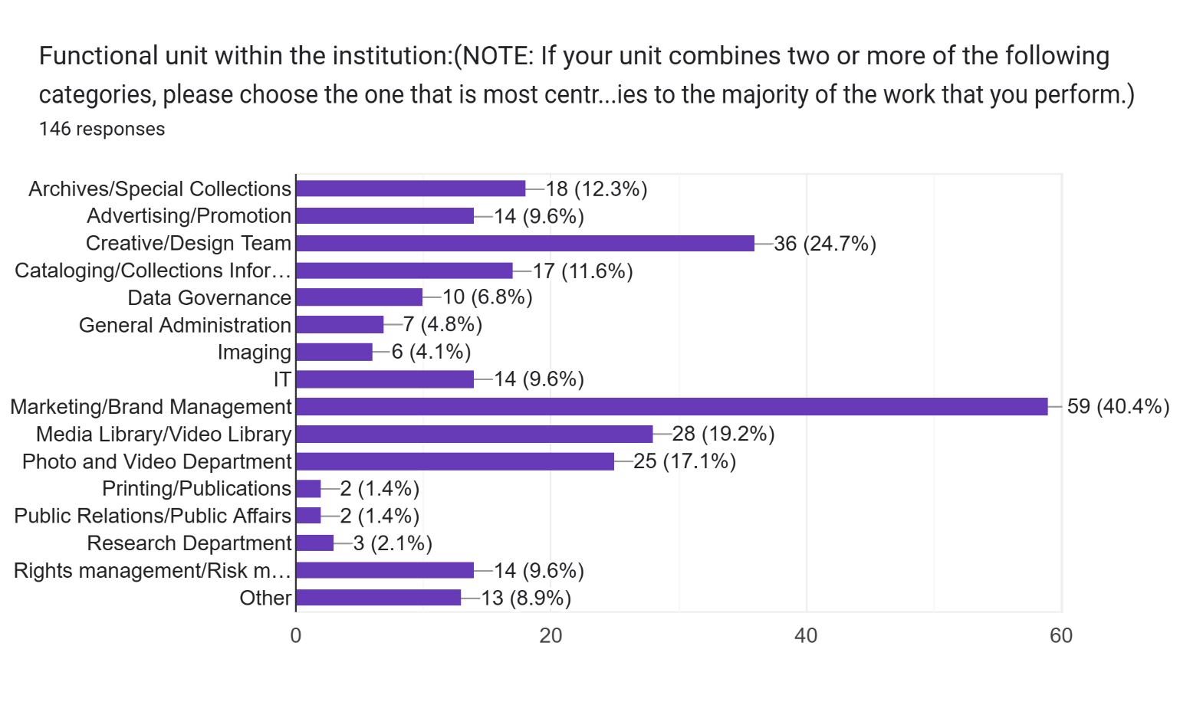

*Figure 4: Responses to the 2024 Digital Asset Management Salary Survey showing a wide range of placements within organizations.*

In the three previous surveys, it was noted that there was a strong correlation between Digital Asset Managers who made less and employment in an Archives/Special Collections unit. This survey shows that correlation is no longer true. Of the 2024 Digital Asset Management Salary Survey respondents reported to be working in Archives and Special collections, 27.78% were in the top third of earners. 16.67% were in the middle third of earners, and 55.56% were in the lowest third of earners. For comparison, Digital Asset Managers who reported being in a Marketing/Brand Management division, which was previously reported to be the functional unit with the best pay, showed a similar percentage of those in the highest income backet – 27.12%. While Digital Asset Management jobs in Marketing/Brand Management divisions did show more of an even spread of salaries, this is due to a wider range of ages and years in the field. Functional units in the 2024 salary survey showed no true correlation to where Digital Asset Managers might be in an organization and their pay.

# Conclusions

The Digital Asset Management field continues to diversify across types of work environments. It is welcome information that experience, and no other related factor is now the sole correlation to earning power within this field.

The raw data associated with these studies (and a copy of this report is posted) here: link.

# Further Reading

We invite others to examine the data and contribute their own findings to the growing literature in the field. To read the three previous publications on this data free of charge, please visit the links below.

Fanslow, Grimm, and Keathley. *DAM Federation 2017 Salary Survey Results*. Originally published by The DAM Federation by DAM News in 2018. <https://www.academia.edu/121944815/DAM_Federation_2017_Salary_Survey_Results>

Keathley, E. *2014/2015* *Results from the DAM Foundation Salary Survey: Human resource trends in a growing profession.* Originally published on the DAM Foundation website, which is now defunct. <https://www.academia.edu/113545202/2014_2015_Results_from_the_DAM_Foundation_Salary_Survey_Human_resource_trends_in_a_growing_profession>

Keathley, E. *Results from the Digital Asset Management Foundation Salary Survey.* Originally published in the Journal of Digital Media Management, Vol 2, issue 1, Fall 2013. <https://www.academia.edu/113544627/Results_from_the_Digital_Asset_Management_Foundation_Salary_Survey>