eMAM Workgroup

December 2013

Configuration
eMAM Workgroup package consists of eMAM Database, eMAM Gateway, eMAM Analytics Gateway, eMAM Director, eMAM Client, eMAM Transcode Manager, eMAM Task Manager, eMAM Archive and eMAM Delivery Service. In eMAM Workgroup configuration, eMAM software components can be deployed in minimum two servers.

eMAM Database/Web Server :
In eMAM Workgroup system configuration, eMAM database and web server components can be installed in one server. We recommend keeping the database and log files in a RAID10 array with daily backup configuration.

eMAM Gateway and eMAM Analytics Gateway will be pointed to the eMAM Database running the same server. eMAM Director and eMAM Client web applications will be deployed in the same server and these components will be pointed to eMAM Gateways running in the same server..
In case of any server failure, a new server can be built with required eMAM components. eMAM database can be restored from the backup or from the RAID array.
Web server components can be installed in a different server (third server) at later stage in case of heavy load.

eMAM Application Server : This consists of one server installed with server based transcoding software, eMAM Delivery Service, eMAM Transcode Manager, eMAM Archive and eMAM Task Manager. All these application components are deployed as backed windows services and these components will be pointed to eMAM Gateways running in the eMAM Database/Web server.

eMAM has the option to configure a less expensive NAS storage or LTO tape library as archive storage. Content can be kept in both online disk storage and archive storage. Disk retention rules can be set in eMAM to move the content from disk storage to archive. Content from the archive can be restored to online disk storage or it can be delivered outside eMAM in any desired file format. eMAM supports partial restore for supported broadcast file formats. Empress recommends LTO library to preserve and protect the content in archive for long term. eMAM requires third party software to manage Robotic LTO libraries.

Main functionalities of application server
- Monitor the watch folders for incoming files
- Transcode the incoming source files and prepare web based proxy copies and other platform files.
- Index and move the source files and proxy files to connected storages.
- Deliver the content from managed storages to external locations.
- Archive the files to NAS storage or the LTO library managed by Xendata, QStar, SGL Flashnet, Crossroads Strongbox or Atempo Digital Archive.
- Restore (including partial) the files to connected disk storage.
In case of any server failure, we can manually bring up these services from another server. Failed jobs can be easily resubmitted from the eMAM Director Dashboard.

Online disk storage : eMAM stores the original and proxy files in an online disk storage for immediate access. Storage size can be determined based on the daily ingest volume and the amount of content needs to be kept in the online disk storage. eMAM has built in options to move the content from online storage to archive storage based on storage threshold, archive threshold (days) and other archive rules. Online disk storage can be a NAS, DAS or SAN storage depends on the customer requirements. Additional third-party software may require connecting to the multi-write SAN volumes.

Cloud Storage (Optional): eMAM can store the content in Amazon S3 storage buckets. Optional eMAM S3 connector can upload the original files and proxy files into separate cloud storage buckets. Content that exist in these buckets can be presented through Amazon CloudFront (CDN) URL within eMAM. For example, if somebody tries to preview a video from Los Angeles, the video will be loaded from a datacenter in Los Angeles. If somebody tries to preview the same video from London, the video will be loaded from a datacenter near to London. Cloud storage can be utilized for offsite archive purpose too.

Hardware Specification for eMAM Database/Web Server
Specification (Provided by System integrator/Customer)
2 x Intel Six core processors (12 Cores), 2.66Ghz or higher
16GB RAM
2 x 146GB 15K RPM HDD on RAID1
4 x 146GB 15K RPM HDDs on RAID10
1Gpbs/10Gbps NIC

Software
Microsoft Windows 2008 R2 Standard (Provided by System Integrator/Customer)
Microsoft SQL Server 2008 R2 Standard (Provided by System Integrator/Customer)
eMAM Database (Provided by Empress)
eMAM Gateway (Provided by Empress)
eMAM Analytics Gateway (Provided by Empress)
eMAM Director (Provided by Empress)
eMAM Client (Provided by Empress)

Hardware Specification for eMAM Application Server

Specification (Provided by System Integrator/Customer)
2 Intel Six core processors (12 Cores), 2.66Ghz or higher
16GB RAM
2 X 146GB 15K RPM HDD on RAID1
4 X 300GB 10K RPM HDD on RAID10 (This is a high speed temporary buffer storage for eMAM for transcoding)
1Gpbs/10Gbps NIC
Optional FiberChannel Card for storage connection

Software
Microsoft Windows 2008 R2 Standard (Provided by System Integrator/Customer)
Microsoft Office 2007 Standard (Provided by System Integrator/Customer)
eMAM Transcode Manager (Provided by Empress)
eMAM Task Manager (Provided by Empress)
eMAM Delivery Service (Provided by Empress)
eMAM Archive (Provided by Empress)

Hardware Specification for Online Storage
NAS/DAS/SAN storage that can support CIFS/SMB or NTFS (Provided by System Integrator /Customer)

Hardware Specification for Archive Storage (Optional)
NAS storage that can support CIFS/SMB (Provided by System Integrator/Customer)

OR
Robotic LTO Library (Provided by System Integrator/Customer)

Specification for Cloud Storage (Optional)
Purchase the cloud services from Amazon and provide the account configuration details to eMAM implementation team.
- http://aws.amazon.com/s3/
- http://aws.amazon.com/cloudfront/
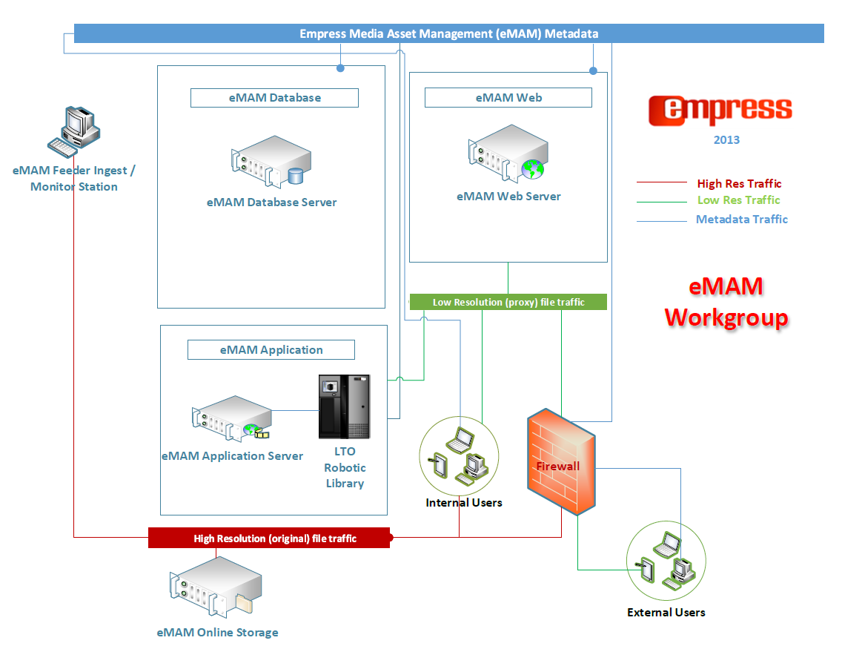
* Empress Media Asset Management is a software company concentrating on building industry leading MAM software. Through our partner eco system, we provide complete turkey solution including hardware and third party software.

