eMAM Vault

December 2013

Configuration
eMAM Vault software package consists of eMAM Database, eMAM Gateway, eMAM Analytics Gateway, eMAM Director, eMAM Transcode Manager, eMAM Task Manager, eMAM Archive and eMAM Delivery Service. In eMAM Vault configuration, eMAM software components can be deployed in one server.

eMAM Database/Web/Application Server :
In eMAM Vault system configuration, eMAM database, web and application server components are installed in one server. We recommend keeping the database and log files in a RAID10 array with daily backup configuration. For the high transcoding requirements, we recommend to run the server based transcoding engine and eMAM application server components from a separate server.

eMAM Gateway and eMAM Analytics Gateway will be pointed to the eMAM Database running in the same server. eMAM Director application will be deployed in the same server and these components will be pointed to eMAM Gateways running in the same server.

Server based transcoding software, eMAM Delivery Service, eMAM Transcode Manager, eMAM Archive and eMAM Task Manager are deployed in the same server or a separate server depends on the ingest, archive and delivery volume. All these application components are deployed as backed windows services and these components will be pointed to eMAM Gateways.

eMAM uses less expensive NAS storage or LTO tape library as archive storage. Content can be kept in both online disk storage and archive storage. Disk retention rules settings are available in eMAM to automatically move the content from disk storage to archive. Content from the archive can be restored to online disk storage or it can be delivered outside eMAM in any desired file format. eMAM supports partial restore for supported broadcast file formats. Empress recommends LTO library to preserve and protect the content in archive for long term. eMAM requires third party software to manage Robotic LTO libraries.

Main functionalities of eMAM Vault
- Monitor the watch folders for incoming files
- Automatically transcode the incoming source files and prepare web based proxy copies and other platform files.
- Index and move the source files and proxy files to connected storages.
- Deliver the content from managed storages to external locations.
- Archive the files to NAS storage or the LTO library managed by Xendata, QStar, SGL Flashnet, Crossroads Strongbox or Atempo Digital Archive.
- Restore (including partial) the files to connected disk storage.
In case of any server failure, we can manually bring up these services from another server. eMAM database can be restored from the backup or from the RAID array. Failed jobs can be easily resubmitted from the eMAM Director Dashboard.

Archive Appliance / Archive Server : This server is required to manage a robotic LTO library. eMAM Archive module will interface with the archive server/appliance to perform archive, restore and partial restore functions from LTO tapes.

Online disk storage : eMAM stores the original and proxy files in an online disk storage for immediate access. Storage size is determined based on the daily ingest volume and the amount of content needs to be kept in the online disk storage. eMAM has built in options to move the content from online storage to archive storage based on storage threshold, archive threshold (days) and other archive rules. eMAM uses NAS, DAS or SAN storage as online disk storage depends on the customer requirements. Additional third-party software may require connecting to the multi-write SAN volumes.

Cloud Storage (Optional): eMAM stores the content in Amazon S3 storage buckets using eMAM S3 connector application. eMAM S3 connector can upload the original files and proxy files into separate cloud storage buckets. Content that exist in these buckets are presented through Amazon CloudFront (CDN) URL within eMAM. For example, if somebody tries to preview a video from Los Angeles, the video will be loaded from a datacenter in Los Angeles. If somebody tries to preview the same video from London, the video will be loaded from a datacenter near to London. Some cases, cloud storage is used as offsite disaster recovery option.

eMAM Client (Optional): This is a web interface for eMAM end users who want to review and share content. This is a completely customizable interface that can be branded for different customers. eMAM Client is installed with other eMAM components or it can be installed in one or more servers depending on the requirement of the client. This component can be installed in a Virtual Server as well. This is an optional component.

Hardware Specification for eMAM App/Database/Web Server
Specification (Provided by System integrator/Customer)
2 x Intel Six core processors (12 Cores), 2.66Ghz or higher
16GB RAM
2 x 146GB 15K RPM HDD on RAID1
4 x 146GB 15K RPM HDDs on RAID10
2 X 300GB 10K RPM HDD on RAID0 (This is a high speed temporary buffer storage for eMAM for transcoding)
1Gpbs/10Gbps NIC
Optional Fiber channel connection to storage

Software
Microsoft Windows 2008 R2 Standard (Provided by System Integrator/Customer)
Microsoft SQL Server 2008 R2 Standard (Provided by System Integrator/Customer)
Microsoft Office 2010 Standard (Provided by System Integrator/Customer)
eMAM Database (Provided by Empress)
eMAM Gateway (Provided by Empress)
eMAM Analytics Gateway (Provided by Empress)
eMAM Director (Provided by Empress)
eMAM Client (Provided by Empress)
eMAM Transcode Manager (Provided by Empress)
eMAM Task Manager (Provided by Empress)
eMAM Delivery Service (Provided by Empress)
eMAM Archive (Provided by Empress)

Supported Archive appliances
Xendata SX-520 Series, Xendata SX-10 Series http://www.xendata.com/products09/products.html
Crossroads Strongbox T10, T20, T30 http://www.crossroads.com/data-archive-products/strongbox
1Beyond EzStor : http://1beyond.com/product-categories/information/ezstor-lto-library-system-ltfs-library-solution
Hardware Specification for custom Archive Server
Specification (Provided by System integrator/Customer)
Single Xeon Six core processor
32GB RAM
2 x 146GB 15K RPM HDD on RAID1
6 x 1 TB 7.5K RPM HDD on RAID50 for archive disk cache, 512 MB RAID disk cache
1Gpbs/10Gbps NIC
Fiber channel/SAS connection to LTO Library

Software
Archive middleware software from SGL, Xendata, QStar, Atempo and Archiware (Provided by System Integrator/Customer)
Microsoft Windows 2008 R2 Standard (Provided by System Integrator/Customer)
Hardware Specification for Online Storage
NAS/DAS/SAN storage that can support CIFS/SMB or NTFS (Provided by System Integrator /Customer)
Hardware Specification for Archive Storage
Robotic LTO Library (Provided by System Integrator/Customer)
AND/OR
NAS storage that can support CIFS/SMB (Provided by System Integrator/Customer)

Specification for Cloud Storage (Optional)
Purchase the cloud services from Amazon and provide the account configuration details to eMAM implementation team.
- http://aws.amazon.com/s3/
- http://aws.amazon.com/cloudfront/
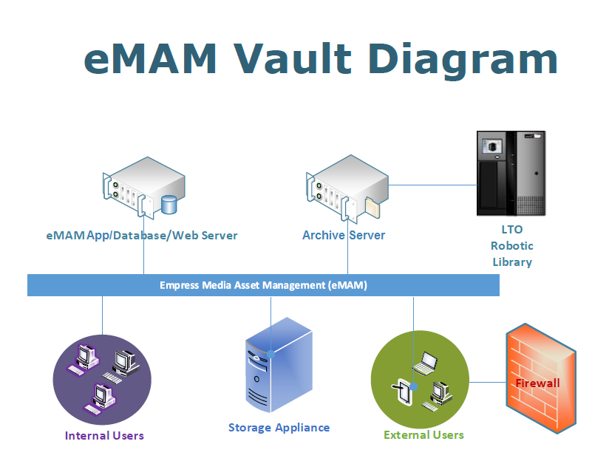
* Empress Media Asset Management is a software company concentrating on building industry leading MAM software. Through our partner eco system, we provide complete turkey solution including hardware and third party software.

