eMAM Enterprise System

April 2012

Prepared By:
Anoop Thomas
anoop@empressmam.com
+1.888.808.3856 x 302

Configuration
Database- Automatic failover clustering
Web server - Network load balancing and failover clustering
Application – Manual Failover
eMAM Database Cluster : This consists of two servers loaded with Microsoft SQL Server 2008 R2 to host eMAM database. Database clustering can be achieved with two nodes of identical server hardware and SAN storage. Microsoft SQL Server 2008 R2 Enterprise, Microsoft Windows Server 2008 R2 failover clustering feature and the Microsoft Distributed Transaction Coordinator (MSDTC) will be installed in the cluster nodes to achieve database automatic failover. eMAM database and transaction log will be placed in separate RAID arrays in the SAN storage.

eMAM Application components will be pointed to the clustered instance of SQL server. By default, SQL Server and eMAM Database executables will be running from node 1 of the database cluster (Active). In case of any failure with node1, database services will be automatically failover to node 2. This failure will not be visible to the end users other than a few seconds of service interruption in the eMAM user interfaces during the failover process.

eMAM Web Cluster : eMAM Gateway, eMAM Director, eMAM Client and eMAM Mobile will be running from two server nodes that are configured to perform automatic failover and network load balancing. The Microsoft Network Load Balancing (NLB) feature installed in the server nodes will distribute the web requests coming from end users to different nodes based on the availability and workload. If any of the server nodes fail, the other server node will fulfill the request coming from the end users. Whenever, there is an increase in load, we can easily add more nodes into eMAM web server cluster and distribute the load.

eMAM Application Server : This consists of one server installed with transcoding software, eMAM Delivery Service, eMAM Cloud Connector, eMAM Transcode Manager and eMAM Archive. eMAM Application server is mainly responsible for making low resolution copy of the source file for web based preview, synchronize the content in the online storage with cloud storage and archive/restore/deliver the assets. In case of any failure, we can manually bring up those services from another server. Failed jobs can be easily resubmitted from the eMAM Director Dashboard.
(This architecture will be difficult to implement as a combined direct attached / SAN storage environment because the same storage volume has to be shared between application servers. NAS storage is recommended here.)

iSCSI SAN Storage : This is the minimum requirement to build a SQL server cluster with one active node and one passive node. This storage should have at least two iSCSI connections.

(Similar configuration of Dell EqualLogic PS4100XV)
http://www.windowsservercatalog.com/item.aspx?idItem=c7785122-718b-2180-7eab-473f12a1dfaa&bCatID=1511

Online Storage : eMAM stores the original and proxy files in an online storage for immediate access. Storage size can be determined based on the daily ingest volume and the amount of content needs to be kept in the online storage. eMAM has built in options to move the content from online storage to archive storage based on storage threshold, archive threshold (days) and other archive rules. This can be a NAS, DAS or SAN storage depends on the architecture. In the configuration illustrated the online storage will be used for distribution media only not for the graphics archive.

Archive Storage: eMAM has the option to configure a less expensive NAS storage or LTO tape library as archive storage. Content can be kept in both online storage and archive storage. There are additional rules in eMAM to manage the lifetime of the content in online storage that already exists in archive. Content in the archive can be restored back to online storage or it can be delivered outside eMAM in any desired file format. eMAM supports partial restore for broadcast file formats.

Cloud Storage: eMAM can store the content in Amazon S3 storage buckets. eMAM Cloud connector can upload the original content and proxy files into separate cloud storage buckets. Content that exist in these buckets can be presented through Amazon CloudFront (CDN) URL within eMAM. For example, if somebody tries to preview a video from Los Angeles, the video will be loaded from a datacenter in Los Angeles. If somebody tries to preview the same video from London, the video will be loaded from a datacenter near to London. Cloud storage can be considered as an archive storage too.

eMAM Disaster Recovery (DR) System : We can install the eMAM components in one server to make offsite DR system. Database will be periodically backed up from production system to DR system. DR storage is not mandatory for eMAM if the content is stored in the cloud. Whenever there is any downtime in production environment, we can easily bring up the DR system by making the database online and perform some IP/Domain configuration changes.

Hardware Specification for eMAM Database Cluster
eMAM Database Server node – 1 (Active)
Specification (Provided by Customer or Empress)
2 x Intel Six core processors (12 Cores), 2.66Ghz or higher
16GB RAM
2 x 146GB 15K RPM HDD on RAID1
Additional NIC ports for iSCSI connection

Software
Microsoft Windows 2008 R2 Enterprise (Provided by Customer or Empress)
Microsoft SQL Server 2008 R2 Standard (maximum two nodes in the cluster) (Provided by Customer or Empress)
eMAM Database (Provided by Empress)

eMAM Database Server node – 2 (Passive)
Specification (Provided by Customer or Empress)
2 x Intel Six core processors (12 Cores), 2.66Ghz or higher
16GB RAM
2 x 146GB 15K RPM HDD on RAID1
Additional NIC ports for iSCSI connection

Software
Microsoft Windows 2008 R2 Enterprise (Provided by Customer or Empress)
Microsoft SQL Server 2008 R2 Standard (no separate license requirement for passive node)
eMAM Database (Provided by Empress)

Hardware Specification for eMAM Web Cluster

eMAM Web Server – Node 1

Specification (Provided by Customer or Empress)
2 Intel Quad core processors (8 Cores), 2.5Ghz or higher
8GB RAM
2 X 146GB 10K RPM SAS HDD on RAID1

Software
Microsoft Windows 2008 R2 Enterprise (Provided by Customer or Empress)
eMAM Gateway (Provided by Empress)
eMAM Director (Provided by Empress)
eMAM Mobile (Provided by Empress)
eMAM Client (Provided by Empress)

eMAM Web Server – Node 2

Specification (Provided by Customer or Empress)
2 Intel Quad core processors (8 Cores), 2.5Ghz or higher
8GB RAM
2 X 146GB 15K RPM SAS HDD on RAID1

Software
Microsoft Windows 2008 R2 Enterprise (Provided by Customer or Empress)
eMAM Gateway (Provided by Empress)
eMAM Director (Provided by Empress)
eMAM Mobile (Provided by Empress)
eMAM Client (Provided by Empress)

Hardware Specification for eMAM Application Server
eMAM Application Server

Specification (Provided by Customer or Empress)
2 Intel Six core processors (12 Cores), 2.66Ghz or higher
16GB RAM
2 X 146GB 15K RPM HDD on RAID1
4 X 300GB 10K RPM HDD on RAID10 (This is a high speed temporary buffer storage for eMAM for transcoding)

Software
Microsoft Windows 2008 R2 Standard (Provided by Customer or Empress)
Microsoft Office 2007 Standard (Provided by Customer or Empress)
eMAM Transcode Manager (Provided by Empress)
eMAM Cloud Connector (Provided by Empress)
eMAM Delivery Service (Provided by Empress)
eMAM Archive (Provided by Empress)

Hardware Specification for iSCSI SAN Storage
Dual storage controllers
15K SAS hot-pluggable hard disk drives
At least 2TB storage (for eMAMdb, log file, tempdb and eMAM patches)

(Similar configuration of Dell EqualLogic PS4100XV)
http://www.windowsservercatalog.com/item.aspx?idItem=c7785122-718b-2180-7eab-473f12a1dfaa&bCatID=1511
This can be any storage provided by Customer or Empress that supports SQL Server failover clustering.

Hardware Specification for Online Storage
NAS storage that can support CIFS/SMB (Provided by Customer or Empress)
Hardware Specification for Archive Storage
NAS storage that can support CIFS/SMB (Provided by Customer or Empress)
OR
Specification for Cloud Storage
Purchase the cloud services from Amazon and provide the account configuration details to eMAM implementation team.
- http://aws.amazon.com/s3/
- http://aws.amazon.com/cloudfront/
Hardware Specification for eMAM Disaster Recovery (DR) System
eMAM DR Server

Specification (Provided by Customer or Empress)
2 Intel Six core processors (12 Cores), 2.66Ghz or higher
24GB RAM
2 X 146GB 15K RPM HDD on RAID1
4 X 300GB 10K RPM HDD on RAID10 (This is a high speed temporary buffer storage for eMAM for transcoding)

Software
Microsoft Windows 2008 R2 Standard (Provided by Customer or Empress)
Microsoft Office 2007 Standard (Provided by Customer or Empress)
eMAM Gateway (Provided by Empress)
eMAM Database (Provided by Empress)
eMAM Director (Provided by Empress)
eMAM Client (Provided by Empress)
eMAM Cloud Connector (Provided by Empress)
eMAM Transcode Manager (Provided by Empress)
eMAM Delivery Service (Provided by Empress)

eMAM DR Storage
NAS storage that can support CIFS/SMB (Provided by Customer or Empress)
This is not a mandatory component if both graphics and internal workflow decided to keep the content in cloud storage.

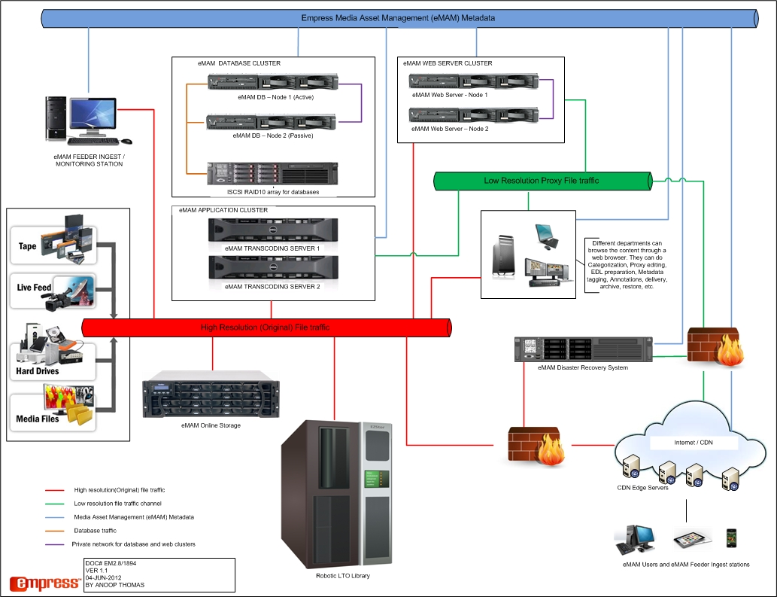
Follow the clustering guidelines from Microsoft during the hardware procurement stage.
http://msdn.microsoft.com/en-us/library/ms179410.aspx
http://www.microsoft.com/en-us/server-cloud/windows-server/failover-clustering-network-load-balancing.aspx

